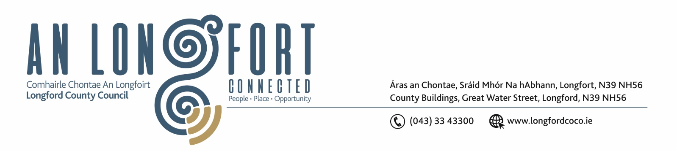

7u Mi na Nollag 2017

Chuig: Gach Ball don Chomhairle.

A Chomhairleoir,

Iarrtar ort bheith i láthair ag Cruinniú Míosuil Chomhairle Chontae Longfoirt a tionólfar i
The Village Inn, Drumlish ar an Cheadaoin, 13u Mi na Nollag 2017 ag 4.00 p.m chun gnó a dhéanamh d’réir an Chláir thíos.

You are requested to attend the Monthly Meeting of Longford County Council to be held in
The Village Inn, Drumlish on Wednesday, 13th December 2017 at 4.00 p.m. to transact business, as set out on the Agenda hereunder.

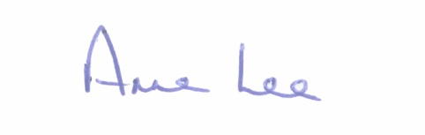
Mise le meas,

__________________
Anne Lee,
Meetings Administrator.

C L A R

- Confirmation of Minutes of the following meetings of Longford County Council -

- Monthly Meeting held on the 8th November 2017.
- Finance Committee Meeting held on the 20th November 2017.
- Budget Meeting Meeting held on the 27th November 2017.
- copies enclosed.

- Matters arising from Minutes.

- (a) Consideration of the filling of casual vacancy in the membership of Longford County Council following the resignation of Councillor Padraig Loughrey in accordance with Section 19 of the Local Government Act 2001 - correspondence enclosed.

(b) Appointment of one member to the following Committees –
(i) Longford Pool Construction Ltd.
(ii) Local Traveller Accommodation Consultative Committee.
(iii) County Longford Heritage Forum.
(iv) Joint Policing Committee.
(v) Economic Development and Enterprise Strategic Policy Committee.

- To note Chief Executive Orders - enclosed

5. To note Monthly Management Report - enclosed.

6. To note adopted Minutes of Corporate Policy Group Meeting held on
11th October 2017 - (copy enclosed).

7. Finance & Information Systems.
(a) To note Public Liability Claims received during November 2017.

(b) Consideration of the Local Government Audit Service Statutory Audit Report for the year ended 31st December 2016 – enclosed.

8. Housing, Infrastructure, Environment & Emergency Services.

(a) Consideration of disposal of Freehold Interest of Property at No. 9 The Demesne, Longford
to Padraig Nugent in accordance with the terms of Section 183 of the Local Government Act 2001 issued on the 13th November 2017.

(b) Consideration of Disability Action Plan – enclosed.

(c) Notices of Motions, submitted by Councillors, as listed hereunder -

Councillor Gerry Warnock.

“I am proposing that Longford County Council initiate a review of our Housing Maintenance Policy with particular emphasis on updating our policy in respect of Heating Systems; Securing and Clearing Voids; and putting in place formal procedures and structured timelines to enable us to process requests in a more uniform and expedient manner thus delivering a more efficient service to customers and limiting the Council’s exposure to potential public liability issues. I am further proposing that this item be placed on the agenda for the next meeting of the Housing Strategic Policy Committee for consideration.”

“I am proposing that Longford County Council again writes to the Minister for Housing and An Taoiseach to reinforce the need to carry out a review of the Income Thresholds to qualify for Housing Support with a view to increasing the maximum thresholds to adequate levels reflecting the soaring costs of rent in the private accommodation since thresholds were introduced in 2011. The current restrictions are prohibiting families on relatively low incomes from applying for Housing Support

9. Economic and Community Development, Planning, Human Resources & Corporate Services, Cultural & Recreational Services.

- To note Planning Applications received since November meeting of the Council.

- To note Review of Corporate Plan 2015–2019 and to adopt Equality and Human Rights
Statement - enclosed.

- To Note Wet and Wild Lands - A Shared Ambition, the roadmap for the development of
Lough Ree and the Mid-Shannon.

- Update on Northern Quarter and to consider recommendation from Executive in relation to
the proposed sale of Connolly Barracks

- (i) Political Donations - Local Elections (Disclosure of Donations
and Expenditure ) Act 1999, as amended - Members of Local Authorities.

(ii) Political Donations - Local Elections (Disclosure of Donation
and Expenditure ) Act 1999, as amended - Third Parties.
(Guidelines and form(s) to be circulated )

(f) To note date for Reception for the following - 11th January 2018 at 7.00 p.m. -
- Longford Pony Club.
- Longford Rugby Club Leinster League Winners,
- Longford Rose of Tralee.
- Cian McPhilips Longford Athletics Club.

(g) Notices of Motions, submitted by Councillors, as listed hereunder -

Councillor Peggy Nolan.

“I am asking that a commemorative plaque be erected in the Garden of Remembrance, Great Water Street, in recognition of the contribution to peace worldwide made by the men from County Longford who served with distinction as members of the U.N. in Jadotville, Cyprus and Lebanon.

Councillor Michael Carrigy.

“I call on Longford County Council to look into the possibility of Longford twinning with Baltimore Maryland USA to try to maximize the benefit to Longford from the large number of US visitors who come to Ireland every year. We have a unique link with the city and state which do not promote at present.”

10. General

- Correspondence – circulated.

- Letter dated 9th November 2017 received from Mr. Denis Naughten, T.D., Minister for Communications, Climate Action & Environment regarding the Post Office Network.
- Letter dated 6th December 2017 received from the Office of the Minister for Finance and Public Expenditure and Reform regarding Mortgage Interest Relief.

(ii) Notices of Motions, submitted by Councillors, as listed hereunder –

Councillor Gerry Warnock.

I am proposing that Longford County Council contact both Irish Rail and the Minister for Transport outlining our displeasure following the recent decision to reduce the capacity of the Friday 17.15 Service from Connolly to Longford by 50% to increase capacity on the Friday 16.14 Service from Pearse to Drogheda. This is an extremely regressive measure to probably the busiest service of the week on the Dublin-Longford line.
It also throws out the wrong message to people living in Rural Ireland, many of whom already feel disenfranchised due to lack of investment in infrastructure, public services and job creation in rural counties, particularly those counties in the Midlands.”

11. Votes of sympathy.

12. Training -
Consideration of Report from Corporate Policy Group.



